AquaVantage

Electronic Scale Control

History
AquaVantage was developed and is manufactured by brothers Dr Mark and Dr Simon Vaughan. AquaVantage as it is presently known was launched on the market during 2001, but its history of development dates back over ten years prior to this.

During the late 1970’s we discovered an article in an old American electronics magazine claiming an electrical current in water, or magnetic field, or electrical field, changed the properties of that water. The article detailed two circuits both sweep frequency generators, creating wave forms similar to that seen in many competitors products available today. The magazine claimed the water no longer scaled pipes, that soaps would lather better, and the water would clean products, skin, dishes etc. better, however success could not be guaranteed and results varied dramtically.

We were asked if we could develop something for this larger pipe market? After several years of further study we launched the first digital industrial descaler in 1994. The product worked well, on a 6ft diameter pipe, while the competition were still scratching to treat a few inches, and our worked better than anyone had expected with substancial increases in scale converstion rates.

Early in 2001 the new name AquaVantage was launched involving a complete range of digital descaling products and a few new enhancements which were long overdue including the new digital domestic and commercial range.

The results have been excellent with major clients such as a whole chain of family name burger stores, major hotel groups, hospitals, government buildings, and large chemical companies all using the product with great satisfaction.

It must be pointed out Dr Mark and Dr Simon Vaughan are electronics engineering, communications engineering, and software specialists, not chemists. Success has been achieved due to special and unconventional electronics skills needed to create and apply the necessary waveforms, these waveforms being based on models built during a consultation with a physicists and chemists at a leading USA University during the early 90’s.
Some of the following is the brothers attempts to unravel parts of the chemistry, it will be open to criticism and has raised much argument between professional chemists some of whom agree and some not. The important issue while we try to understand the mechanisms is that the treatment works.
Basic Overview
What Causes Hard Water?
Calcium carbonate, naturally exists in two forms limestone and marble. Limestone has a number of impurities which are predominantly Silica, Alumina , and calcium sulphate which act as bonding agents.
CaCO3 is only very slightly soluble in water, yet large amounts of calcium become dissolved in most water supplies. This is because as rain water falls to earth it encounters carbon dioxide and reacts with it to form a mild acid (Carbonic Acid). Thus as rain water comes into contact with limestone in the earth, the limestone dissolves and goes into solution with the water. Surface waters also encounter carbon dioxide from the decay of organic materials. As these waters contact limestone, the limestone gradually dissolves and goes into solution.
Under close investigation of industrial systems where scale is formed, the scale is mainly Calcium Carbonate or Magnesium Carbonate but also Silica, Alumina or Calcium Sulphate are required as binders to make the scale form.
How does AquaVantage work?
The AquaVantage wave form changes the Ionic state of the molecules in the solution being treated. This physical ionic change repels Silica, Alumina and Iron which normally act as binders and make scale form. Free electrons are generated which allow Ca (Calcium) and Mg (Magnesium) to dissociate from CO3 (Carbonate), SO4 (Sulphate) and HCO3 (Hyrdocarbonate) and assume their neutral atomic states, thus stopping scale forming and removing scale deposits. On evaporation only neutral minerals form and any Calcium Carbonate left will form as neutral Aragonite instead of Calcite as shown below

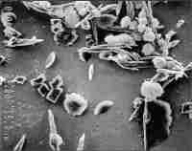 | Electron Microscope evidence of the physical changes generated by AquaVantage | 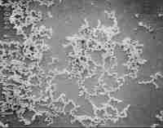
Sample (A) before treatment  magnification level 2000 x  Calcite crystals |  | Sample (B) after treatment  magnification level 2000 x  Aragonite crystals

What is Aragonite?
Aragonite is the orthorhombic crystalline from of Calcium Carbonate. Aragonite is stable at high pressures but will normally revert to the Calcite crystal formation. Aragonite is also 19 times more soluble than Calcite. If a saturation condition occurs the Calcium Carbonate will precipitate as Aragonite and be easily dispersed when the saturation condition is over.
Aragonite occurs in only two instances naturally in the world. Natural oyster pearls are largely formed from Aragonite and as flos ferri. Flos ferri is a massive form of Aragonite (not the individual crystal form produced by AquaVantage) where the masses can resemble coralline growth and is usually deposited by hot springs.

How is AquaVantage applied

The technology involves a coil of wire wrapped about the treatment pipe through which the AquaVantage signal generator passes a complex electrical wave form.
This produces a magnetic (H) field in close proximity to the coil together with an electrical (E) field that travels throughout any continuous stream of water for much greater distances. Pure water is a very poor electrolyte with only slight dissociation of the ions (one molecule in 550 million), the ions of scale in the water actually aid conduction of the EM wave.

You can more simply think of the application like a motor or generator, where if a conductor of a circuit is moved in a magnetic field a current can be shown to be induced in that conductor (Faraday’s Law). Here a magnetic field is formed by the coil, conductive water and the pipe sit in the field, the water is moving, and the field is changing, by the same mechanism a current is induced to flow in the water. Since the signals are in the very low frequency radio spectrum, they are able to travel partly in the air, no closed circuit is needed, the same as radio waves reach your radio.

Many installation engineers carry a pocket transistor radio as when placed close to the pipe you can hear parts of the waveform leaking through into the radios i.f. Stages. It will be strong close to the coil, but can be heard many meters away when placed close to the pipe as the electrical signal travels through the water in the pipe.
In one specific application in Africa, scale was giving problems where water from gold reclamation scaled along the many hundreds of miles of pipes through which it ran to the sea. A salesman hoped to sell many descalers one at each pump station. Unfortunately the trial unit was so successful that the electrical wave form (E Field) managed to travel all the way to the sea. He only sold one unit. This is important where water enters storage tanks, whilst treatment remains effective for several days, the continuing pipe work may be less effectively be treated unless there is a path for the EM wave.

More Discussion upon the Mechanisms involved.

You will come across a multitude of explanations from the industry of electronic water treatment, some related, some true, and many totally untrue, some from highly qualified individuals, some not. To keep things simple we shall try to look independently at many of the effects experienced at installations and possible reasons and mechanisms that might be associated.

A simple analogy whilst not 100% correct is to consider the electrical waveform we have induced to flow in the water, and the study of dipole moments. Water doesn’t truly behave like a fluid, it tends to have structure with each water molecule H-O-H forming a V rather than a straight line. The ends of this molecule have associated charges and like a magnet are attracted or repelled by electrical or magnetic fields. (A small electrical field works well, whereas a massive magnetic field is needed to achieve the same moment). The changing waveform pushes and pulls on these molecules stretching and changing the shape of the V, and as it does so chemicals such as Calcium disolved bewteen the water molecules are thrown out of solution. Due to the collsion energy imparted upon them these form small Aragonite particles. You could just say we electrically shake it so much dissolved things fall out.
The change in water molecule angle used to be a highly argued theory, one we put forward back in 1993 and which at the time received much riducule, thankfully due to the work at London Imperial college on dipole moments and the work of a professor at the UK’s London South Bank University the link is now appears is proven.

Crystal Growth.
We know the wave forms change the type of crystals that grow. Typical calcium carbonate scale forms hard calcite crystals, they have a three dimension shape that fits together like building blocks to form a very hard and difficult to remove structures. Treated water contains orthorhombic small aragonite crystals which are much softer flat crystals that form powder or deposit layers. If the treatment is correctly applied the aragonite crystals are continually agitated by the wave forms so they do not combine to form layers they merely form a powder. If there is enough water flow or turbulence this powder simply flushes away. We can prove the change in crystal formation using a normal microscope with a polarising filter. Here you can see the changes in crystal shape before and after treatment. Independent tests have further attempted to quantify conversion rates which for AquaVantage are around 70 to 80% often achieving over 85%, whilst the majority of the competition fails to achieve 30%.

Water Solubility / Wettability, and Improved soap lathering.
Water , the liquid form of the compound hydrogen oxide, is a colourless liquid of boiling point 100deg C (@760mm Hg Pressure) and freezing point 0 deg C. It has a much higher boiling and freezing points that other hydrites of Group 6 because of its hydrogen bonding. This is also the cause that ice is less dense than its liquid form, the maximum density being at 4 deg C, and accounts for the comparatively high values for its specific heat and heat of vaporisation. AquaVantage treated water appears to have increased solubility and reduced surface tension. This would point that the hydrogen bonds are being effected by the wave form. Water itself does not behave like a true liquid more over like a fluid crystal, the hydrogen bonding between the molecules forming into tetrahedral structures. It is a diamagnetic iso-monotonic structure, i.e. The molecules will align across a magnetic field or electrical field as discussed above. Thus when we apply a continually changing and varying field of the correct nature stress is placed on the molecules as they try to realign, this we believe moves the water away from its tetrahedral structure weakening the hydrogen bonds, freeing ions to improve the solubility as would heating the water. Simply the molecules of water tend to group into clusters of 16 to 18 molecules. The AquaVantage treatment breaks these clusters into groups of 5 to 6 molecules increasing the surface area, and intermolecular space into which ions are dissolved. This has been shown in the US using MRI scanners set at the frequency of Oxygen to illuminate the water molecule cluster size.

The weakened hydrogen bonding lowers the surface tension so that the water becomes wetter and works better with soaps and detergents. Soaps and detergents have two things to do, they must convert the soluble salts to insoluble salts (which form scum), and weaken the surface tension so the water can actually wet the product it is to clean. The AquaVantage treatment seems to aid this process.

This was described as surface molecular energy realignment.
Regarding wettability - in Canada several fire fighting companies are using this technology to reduce the quantity of water required during fire extinguishing. Typically much of the water poured onto a fire runs back off into the ground, the wetter water penetrates objects.
A lead moulding factory in the USA used the product to reduce the required cleaning on their injection moulds. To their surprise they found treated water cooled the mould quicker and consequently were able to increase production.

Aid to plant growth
Several years ago the original product under the Scale Ban name was purchased by the Israeli government desert agricultural research station to eliminate scaling on the irrigation nozzles. To their surprise, they found their plants grew much bigger and faster than the same plants receiving the same water, only untreated. Various explanations have been offered including the possibility that the plants may be more able to make more use of the calcium in its aragonite form than calcite form. The probable cause is more likely to be the effect treated water has in reducing the build up of salts around the plants root structure. You have probably noticed that potted plants need to be regularly re-potted, more so with hard tap water, and much less so with rain water. Plants draw up water and good salts through their roots. Some non required salts are left behind which as more and more water is extracted become more and more concentrated to the point where they inhibit the plants ability to draw up water or good nutrient salts. Consequently the plant starves. The AquaVantage treated water leaches away these bad salts, and improves the solubility of good salts leading to improved plant growth. We are presently conducting further research here in the UK with a local research facility.

Improved Boiler Efficiency
This is simply brought about by the fact that scale is a thermal insulator. If the tubes in your boiler are covered with scale, the heating elements (or heat exchanger) must reach a higher temperature in order to heat the water. As you increase the necessary temperature, so the losses increase and the system becomes more inefficient. The US department of energy amongst other notary bodies have conducted much research on this and publish their own reports regarding boiler efficiency verses thickness of scale. These results are quite alarming as shown below.

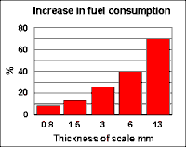

By removing the scale you reduce these inefficiencies. Further more since the water is wetter then heat transfer into the water is also improved. Severe scale build up in boilers can also be dangerous causing excessively high temperatures with explosive results.

Aid to Bacterial Control.
Firstly consider that since bacteria grow well on deposited scale, then by removal of that scale the growth sites are removed. But further to this, research has shown biofilms which harbour and protect bacteria from bactericides are destroyed by passing electricity through water, or by subjecting that water to ultrasonic compression waves. The AquaVantage product generates both, the electrical current due to its E field, and a sonic compression wave due to the physical influence it has upon the magnetic and charged structures within the water. Listen close to the coils, you will hear the audible frequencies. This has shown in many applications that AquaVantage significantly aids bacterial control when used with a bactericide to virtually eradicate bacteria.

Reduce Chlorine Usage in Swimming Pools and Spa’s
Swimming Pools are effected in two ways. Firstly the treated water holds the chlorine gases much longer. Treated sites often notice the radical drop in chlorine odour, thus less chlorine is required to top up the concentration each day. Typical results here reduce chlorine usage by up to 50%. Secondly the chlorine is added to reduce bacteria, the effect of the AquaVantage wave form upon Biofilm often means less chlorine concentrations are actually required to do the job. It should be noted that reducing chlorine levels below the designers figures should be only undertaken with care paying particular attention to regular bacterial tests.
Obviously you also get the advantage of reduced scaling and improved thermal efficiency.
Ice Making Machinery
If you fit AquaVantage a few meters before ice making machinery, you’ll notice the ice cubes formed will be clear, again due to the affect on hydrogen bonding.

APPLICATION
It is important to understand how and where to apply Aquavantage. When controlling scale Aquavantage converts disolved calcium into inert Aragonite powder. Untreated water is near saturated with calcium, when it is be heated, subjected to pressure changes, pH changes etc, the water is no longer able to hold as much calcium so it is deposited as scale. Treated water reduces the saturation by removing the calcium ions and converting these to inert aragonite powder, it can then be subjected to heat, pressure etc, and if enough dissolved ions are converted the water can flow without depositing scale. A high scale conversion rate here is obvioulsy important, a key benefit of the Aquavantage process.
But it is also important to consider where this Aragonite powder might go. In a normal house it may just flush away to waste without issue. But in a recirculatory heating system there is no where for it to go. Most heating systems require regular makeup water, which adds further calcium again and again until it is so loaded scale is going to form. Where a lot of makeup water is used, it is important to monitor the disolved solids and have regular maintenance blow down schedules to remove the aragonite powder.
As an installation engineer you need to think where this will collect, and methods to remove it. In heating applications we apply treatment at least several meters before the scaling event, when there is no where better to apply the treatment, and we must survey for slow water which is where the aragonite sediment will collect and need to be removed by blow down or other means.
If we are treating a cooling tower, the best place to treat is the return pipe to the tower, treated water falls down through the tower reducing any scale there, and the sediment collects in the base sump of the tower where it can be drained away, or removed by syphoning off while still soft. Some large cooling system have a cooling tower and a large separate sump/pool, in these instances it is generally best to treat before the external pool. Argonite will still need to be removed in these cases and can be pumped or dug out, during regular maintanance procedures.

If we treat a swimming pool, we treat the return pipe to the pool. Sediment is removed in the floculation stage, and by the filters as the water exits the pool before it goes to heat exchangers.
In some cases though the sediment cannot be removed. Such plant would always require regular dissassembly and difficult cleaning to remove scale. We cannot stop the formation of deposits under such applications, successful treatment here reduces maintenance since cleaning will be much easier. Soft powder deposits rather than hard scale deposits.

Our criteria for selecting Aquavantage models is the external pipe size of the installation point. This sets the electrical characteristics for building the unit. It is important to thouroughly survey the installation site,
look for scaling events,
a suitable installation point before these events,
suitable power supply point
and very importantly electrical noise which could reduce the treatments effectiveness. Many engineers use their pocket radio tuned between bands as a simple noise scanner. If there is a large amount of noise near the pipe, first look for an alternative application point away from the noise, if that cannot be found, then consult with us, it will probably be necessary to upsize the unit by at least one size to combat the interference.

You will also need to consider environmental issues such as heat, water, which could effect the electronics, physical damage, and even theft. Yes many customers have reported a faulty unit only to find someone has stolen it!!.

Ther are more details below.

AquaVantage Devices Specifications

AquaVantage comes in a range of sizes and ratings for a variety of applications. All units feature a full 20 segment LED bar graph display which indicates all test functions. During power up the system fully tests itself and monitors eight parameters during normal operation including the pipe coil. If the bar graph flashes along the full width, the unit is properly connected and fully functional. The processor in all models is protected by an independent ‘watchdog’ circuit that monitors and resets the processor should a crash occur.

Domestic, Commercial
The commercial units are higher power versions of the domestic.
IP65 ABS RAL7035 enclosure 165 x 85 x 55 mm (Termination's are external and not IP rated) The unit comes with four lugs for wall mounting. It has a full 20 segment bar graph feature, full self test and monitoring features are included. Remote monitoring no volt contacts can be provided as an optional extra.
are included. Remote monitoring no volt relay contacts are provided to signal BMS system should a fault develop.
Suitable for environments up to 55C.
Total packaged weight vary
Internal power supply rated for 90 to 260V AC 50/60Hz
Wall mounted with concealed mounting holes.

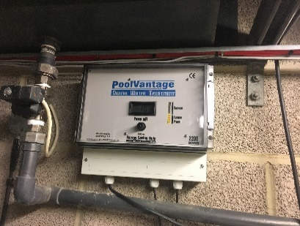

Larger models
Larger models are avalable for pipe sizes from 200mm to beyond 1meter. They are custom made for the task. Pipes from 200mm to 700mm are treated with a single unit, above that we use twin master/slave units.
They are usually based around ABS (polycarbonate optional) Fibox 36-31enclosures with rear monuted heatsink, wall mount brackets and units IE3000 and above have fan cooling.
The case is IP65, Nema1,4,4X,12,13 approved, however the low voltage DC fans are only IP4 rated so will require a rain cover if fitted outdoors. When fitting outdoors also avoid direct sunlight which will quickly overheat the unit before power is even applied. 10cm clearance should also be allowed above and below for air flow through the heatsink.
Internal power supply rated for 90 to 260V AC 50/60Hz, or 120 to 370V DC

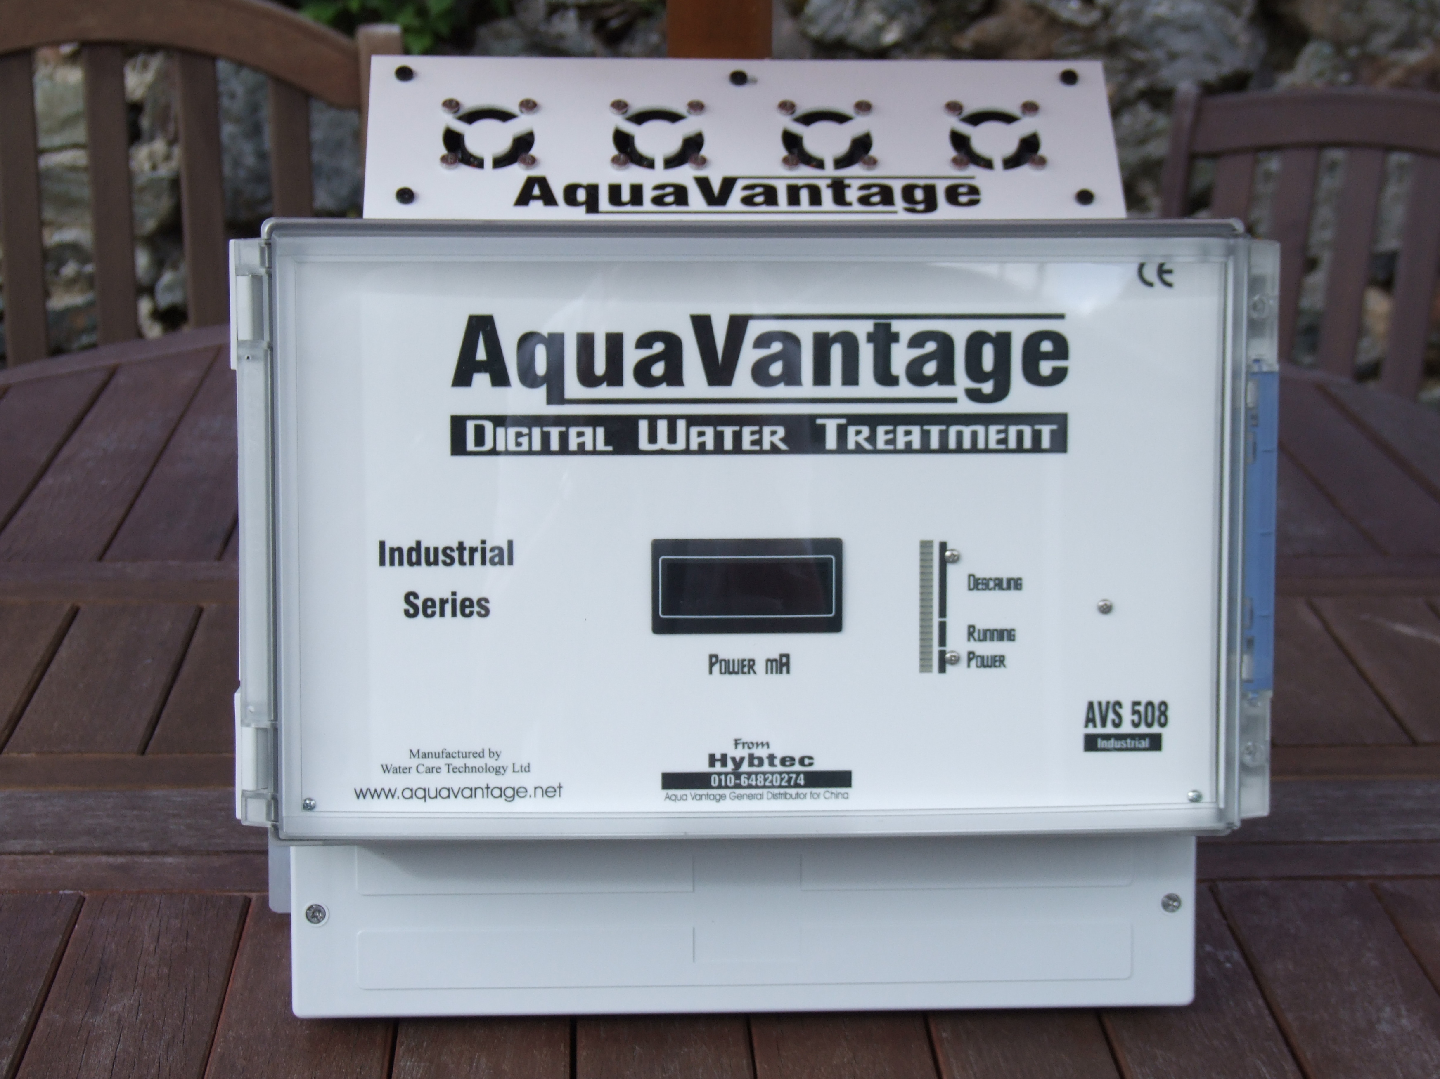

Optional Steel Metal Clad MC Enclosure
Steel enclosures are available for harsh environments in a variety of formats stainless steel, steel, IP65, IP66, IP67 and EExD zone 1 and 2. Enquire when ordering.

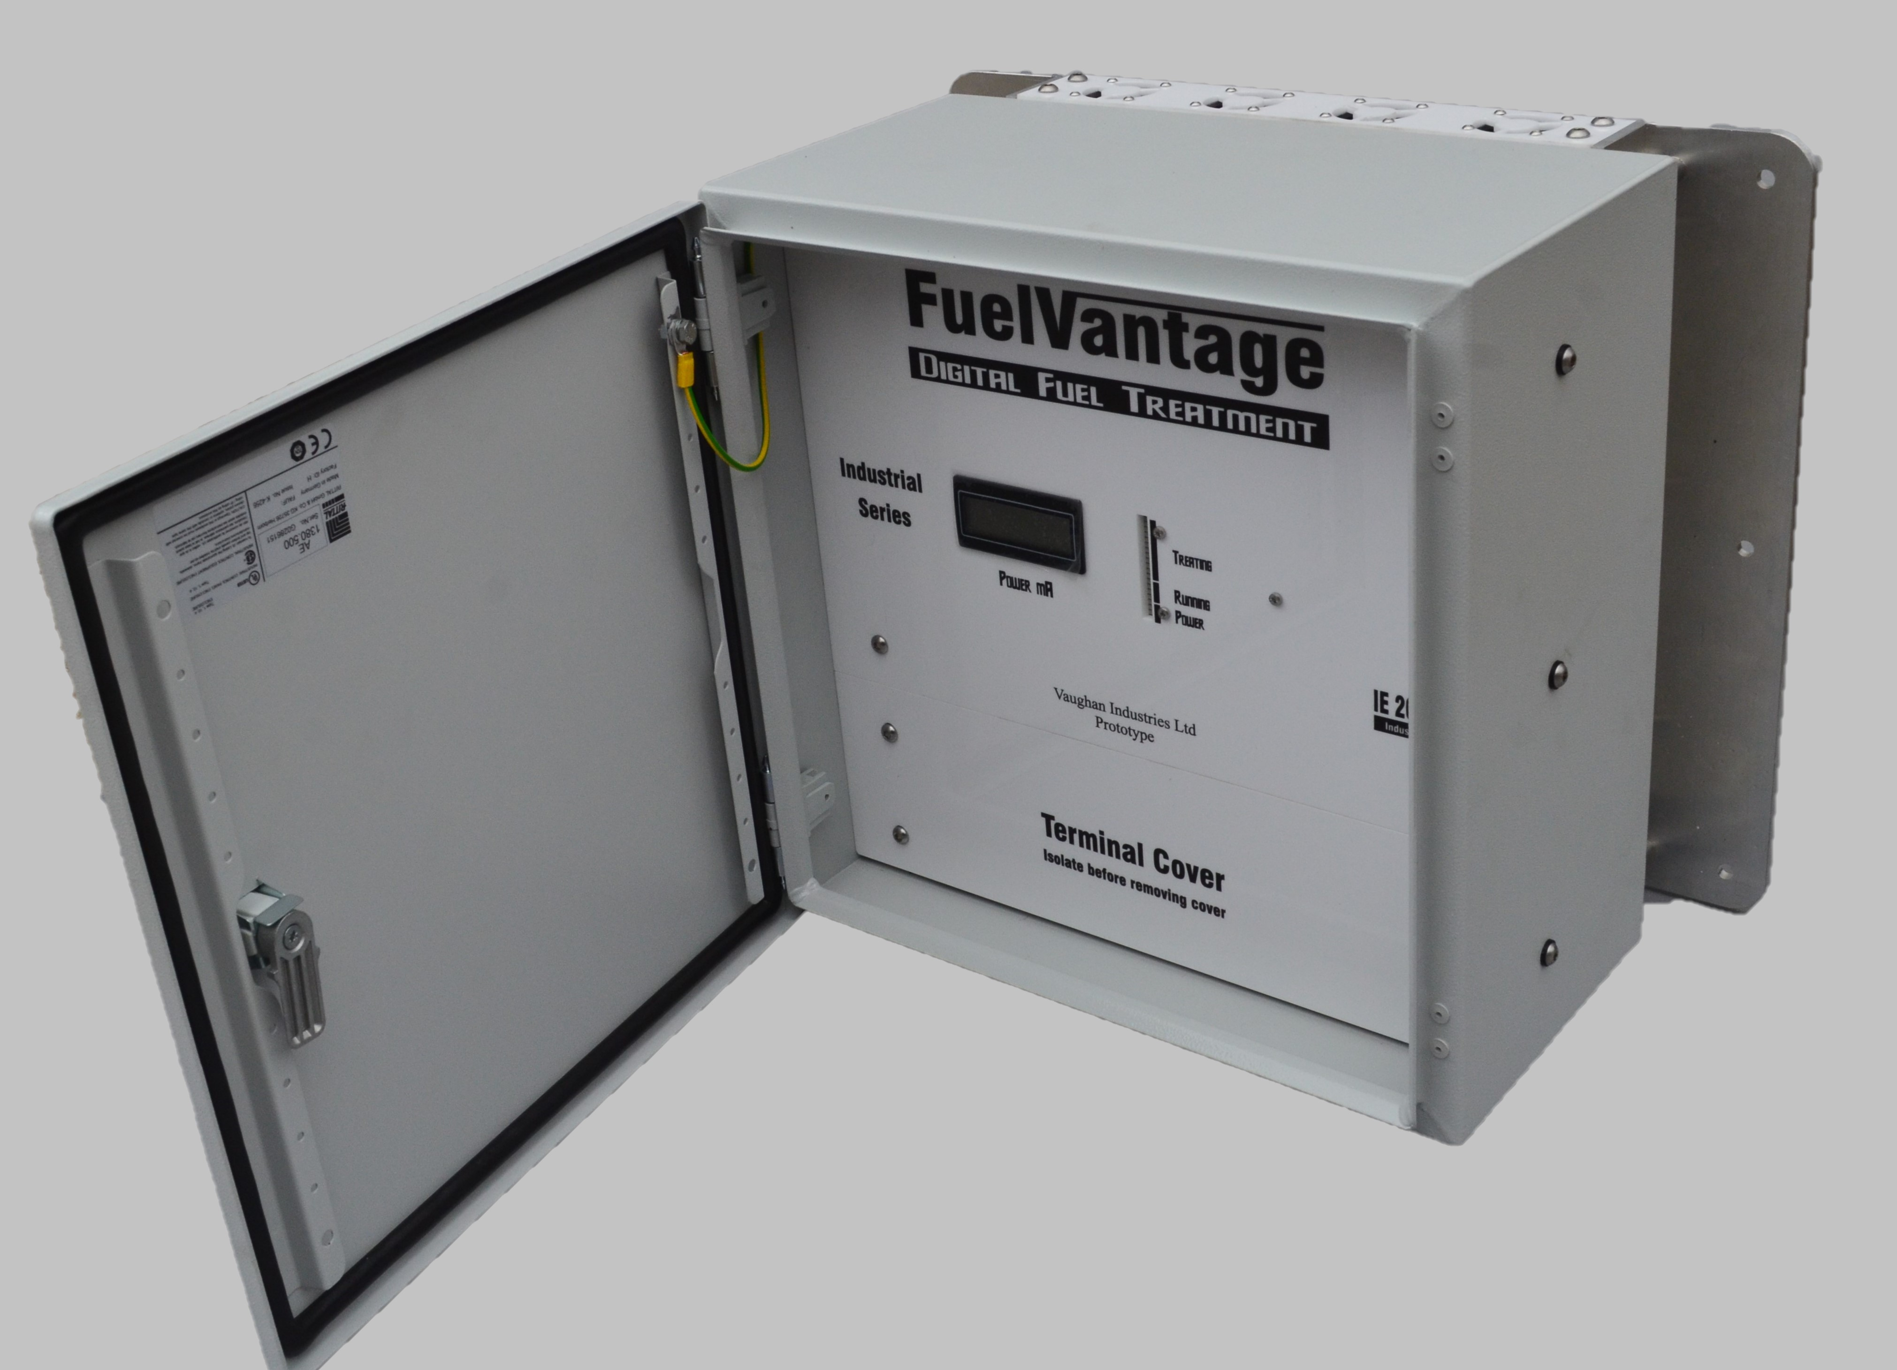
DUAL TECHNOLOGY DT
Our latest recent 2020 release involves our Dual Processor, Dual Technology DT systems to enhance the range.
These use dual microprocessors to produce a closer to ideal waveform, with the ability to monitor external sensors. The systems featute a colour liquid crystal dislay screen, that shows AquaVanatage descaling features but also able to monitor up to four analogue inputs, then based on these parameter control up to four output relays for customer specific features. Additionally the have full modbus interface to report the status of AquaVantage and monitored inputs. (Note one relay is normally picked to provide basic building management features, in applications where modbus isn’t used).

The inputs can be anything from 0-20mA, 4-20mA, 0-5V, 0-12V, 0-24V DC
The relays have 1A changeover output contacts suitable to drive a range of other equipment.
Monitoring and control could for example be TDS with relay output used to automate blow down proceedures based on an adjustable thresholds, of value for on, value for off, or for a time period. They could control or monitor Chlorine, pH, Temperature dosing systems or modbus reporting, Specialised software can be provided for customers with several similar plant applications.

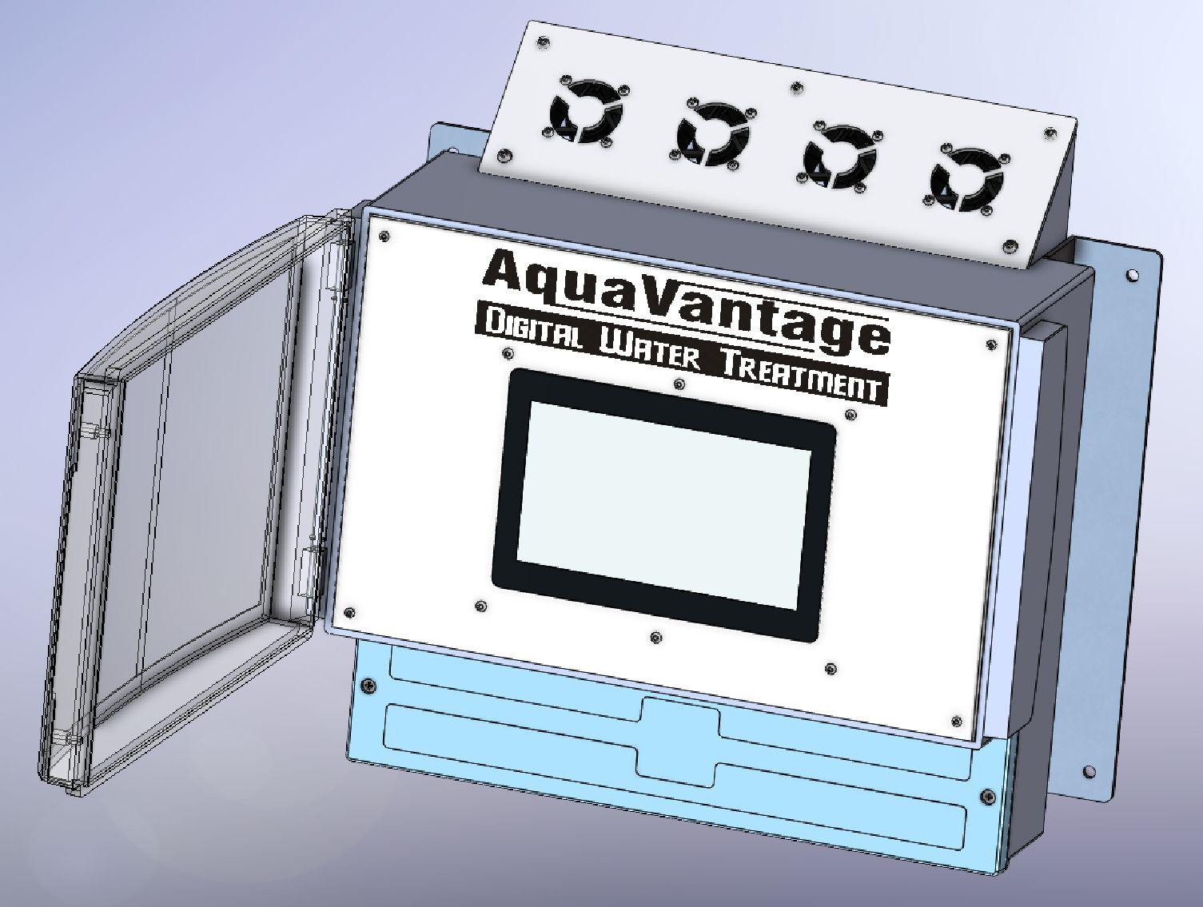

Custom Options

Pipe Coil Wire - The external diameter is the critical factor for this product, other factors to consider include the temperature, and chemical environment.
For details of coil recommendations with suggested wire types see the AquaVantage model plan.

Output Currents
The output current is measured and referenced to special manufacturers test equipment, the exact details remaining confidential. Readings on external meters may vary due to the characteristics of the wave form. Typical bench meters measure a peak or average value and scale that to an RMS equivalent for a pure sinusoidal 50/60Hz mains waveform, they can be very innacurate with the complex Aquavantage waveforms. Even many so called true RMS meters give a variety of dissimilar readings whe presented with the complex AquaVantage waveform though are generally closer. The output current is always set to exceed maximum rating with a typical test pipe loop in our test facility. With large industrial applications, on rare occasions adjustment may be required to the coil windings to achieve maximum power, as shown on the LCD display. The built in Ammeter is a very basic meter, calibrated against the same references on a test load during manufacture it provides us with a known reference avoiding the wide variety of readings found we might otherwise suffer from a variety of commissioning engineers meters.

Frequency
The output wave form consists of an interactive complex set of pulses able to generate the necessary spectral frequency response required to achieve high scale conversion rates. The exact details are confidential, and many critical characteristics are specifically disguised. The fundamental frequencies lie between 1 kHz and 21.5 kHz, with 40KHz region covered by harmonic components, the output is heavily attenuated by 100kHz to avoid FCC issues.
Testing the Unit
On purchasing your first unit you will be tempted to connect a power supply, length of cable and see what happens. Be aware the units are designed to operate with the coil windings as detailed later for its specific pipe size.

DO NOT connect the unit to either end of a reel of wire, the Inductance associated with so many turns could damage the unit. Such damage is not covered under warranty
It is permissible to short circuit the output terminals for short periods in which case you may see output current higher than the rating of the unit. If you wish to perform further burn in tests (for instance after a hazardous transport route) wind the power on the front panel knob down to the units maximum current as shown on the meter and leave for extended burn in, with a suitable pipe coil load connected. When complete re-power unit and ensure self power up test completes as shown by bargraph sweeping along full length.

Note ON SITE WELDING
On site welding can result in high currents of several hundred amps flowing along the pipe, these will be amplified 40-50 times by the treatment coils where the AquaVantage unit could be subjected to very high current, far more than it is able to withstand. If welding is to be carried out onsite, disconnect the power supply AND output coil from the AquaVantage unit.
Surveying for the Installation

There are several important rules to remember when surveying an installation.

    - Find the scaling event so that treatment is applied before the event.
    - Chemically examine the type of scale. Calcium scale in the form of carbonates, bicarbonates, and sulphates can all be treated. However in some applications scale compounds of silica appear visually identical to calcium. Pure silica scale cannot be treated, it is however commonly mixed with other impurities through which silica based scale can be effected. Chemical testing is therefore often required. Nitrate compounds greater than 15ppm will interfere with the E field causing variable results. Whilst pH, temperature, TDS or pressure changes can cause scale formation they do not inhibit the functionality of Aquavantage.
    - Locate the pipes that supply the event, in simple buildings this will be the rising main, or water down services. For calorimeters treat the make up water, and the return between the pump and calorimeter. Again for boilers treat the makeup and return pipes.
    - Consider where scale sediment will settle. On close loop systems, the calium removed from solution will form a sediment that will settle in areas of slow water flow typically a few meters after the treatment area. These need to be identified, and some method established to remove the sediment as it builds with more makeup water. In many cooling tower or calirifer systems there will be a sump where it will collect and can be removed by blowdown, in other systems like swimming pools it will collect in the filters where a reverse flush will remove it. In practice if the TDS is monitored, it will initially drop, then as calcium content builds in the system, there will come a time when it approaches saturation and cannot be treated, indicated by TDS rising, this is the time to clean the system. Customers must be aware of this need.
    - Measure the external pipe size. Any piping coverings or insulation wraps must be cut away so that solenoid coil windings are made directly on the pipe surface. Coverings can be reinstalled on top of the coils afterwards. (ensure cable can withstand temperature within covering, Intemp, or trace heater tape can be used for coils in high temperature applications)
    - Locate location for coils noting following rules:-
    - Coils must be at least Pipe OD x 8 + 1 meter before scaling event but futher is much better.
    - Coils must be at least Pipe OD x 4 away from items that could interfere with the treatment, eg. Bends, T’s, stop cocks, pumps, and noisy electrical equipment.
    - Coil needs wire OD x turns + 50cm of straight pipe onto which the coils are wrapped.
    - Look for electrical supplies to power unit.
    - Look for electrical noise both near the installation, and carried through the treatment pipe. The installation must be located at least 1 meter away from any extraneous electromagnetic fields, such as those generated by high current power lines, electric motors, (Note: electric motors develop the highest field strengths in line with their output shaft. Coil installations perpendicular to the motor shaft are much better.)
Ensure coil location is after any earth cable fitted to the pipe.
Ensure the pipe is free from electrical noise, place a simple transistor radio tuned between stations next to the pipe, listen for electrical noise caused by other electrical appliances leaking current thorough the water system. If significant noise is evident it is better to locate the source and repair the appliance. Alternatively upsizing the unit will often overcome such noise. When installation is finally complete the descaling waveform should obliterate noise when listened to with radio.
    - Deteremine temperature of pipe if above 80 deg C special cable will be required.
    - Temperature of the location, most of the units work satisfactorily in temperatures well above 40 deg C, but 40 degC is a good safety threshold for long product life, if your hand burns on metal in the area it is too hot. For instance avoid putting the unit in direct sunlight or in small enclosures where heat may build up, provide ventilated shade if fitted outdoors.
    - Look for a suitable location to mount AquaVantage box, and determine if IP65 is enough protection. (For outdoor use we recommend installing in further IP67 cabinet, or add a rain shield.) Is the environment considered ‘hazardous’ do you need EEXII enclosures.
    - Determine water conductivity. (This is often used as a non ideal measure of hardness).
If less than 150uSiemens there will be a E field conductivity problem, uprate unit.
If between 150uSiemens, and 300uSiemens treatment should be effective.
If greater than 300uSiemens treatment should be excellent, but for more than 800uSiemens it is again recommended to uprate the unit due to the quantity of scale needing treatment to get the best possible conversion rate.
Uprateing means use unit and power for next pipe size, but winding for actual pipe size.
    - Look for conductivity breaks in water flow. i.e. into tanks after which E field is not conducted. Treated water is often good for 3 days though we recommend a limit of 24 hours. It will generally not scale significantly after the break in conductivity, but there is no field to aid pipe cleaning, only desaturated water. In such circumstances we sometimes recommend treating with AquaVantage both before, and after the conductivity break, or you can establish an electrical bond between incoming and down water services. This can sometimes be achieved with one unit treating two pipes. (see one unit - multipe pipes later), or by fitting a earth strap between across the break.
    - Look for slow flow rates. Minimum flow rate for full treatment: 15cm per second. (for a 15mm pipe that is approximately ¾ Gallon per minute and for a 1½" ID pipe it is 3 Gallons Per Minute. Minimum flow rate to stop aragonite powder settleing, turbulance, or enough flow is required to keep this powder in suspension so that it can be flushed from the system. As a general rule to stop particles settling a flow rate of 3m/sec is required, 2m/sec is often sufficient, but at 1m/second there will be some settling requiring backflushes to remove sediment. Where the water becomes static for any apreciable time we recommend a flow rate of 6m/sec. These are the areas in closed loop systems where sedimant will settle and need cleaning/bowdown, be sure they are accessible.
    - If the system is heavily scaled, look for small orifices in the system that could become blocked by large pieces of scale breaking away. Typical areas are large tanks where scale can come away in chunks several cm’s across. Where this could be a problem for orifices less than 5 mm a filter may be used, and is recommended for orifices below 20 mm. It is also possible with Industrial adjustable Aquavantage units to slow the rate of scale removal by reducing the output power, starting at around 20% of the recommended level, and increased gradually over days whilst monitoring the scale the is being removed from the system.
    - Establish a method with the customer to monitor and validate the unit is working.

Undertaking the Installation

Select where you intend to put the control unit.
The control unit should be preferably within 2 meters (6 feet) of the pipe coil assemblies. You will have already established these locations during your initial survey.
Domestic and Commercial AV units have multiformat mounting lugs offering eight possible mounts through which the unit can be screwed to the wall. If unused lugs interfere with adjacent equipment they can simply be cut away.
LI and Ind units have three mounting holes. The upper mounting is key holed, and the lower two mounting holes are accessed behind the lower termination cover.
IE have four mounitng holes in the alloy mounting brackets.
Smaller AV units come with screws and rawl plugs.
Larger units come with glands, but fixings are job specific and not gerenally supplied.

Assembling the Signal Cable and coils

  - The Control box has knockouts for PG11 19 mm type cable glands (3-5 supplied, ). Drill these out and trim with a knife, you will need one gland for power supply cable, and two for output A to A end of coils, and return B from B end of coils, twice this for parrallel wired coils. Ensure the holes are cleanly cut to ensure a water tight seal with the gland.
  - The output connectors are located under the terminal cover with four commoned terminals for each output to ease a variety of installation requirements. Thread the cable through the cable gland fitted close to the output terminals marked A. Strip the end of the wire is stripped to reveal about 1 cm (3/8 inch) of copper wire. (For multiple core cable, join the conductors at each end together, or use the multiple common terminals provided) Twist the bare wires together, and insert into one of the terminals marked A and secure with screw. (Note we are moving over to Wago cage clamp terminals in many versions, these are operated by lifting the orange lever to open, and flipping it down to secure the cable)
  - Take the cable to the pipe to be treated. Leaving a little slack so that the cable to the unit is not tight, secure the cable to the pipe with a cable tie, or several joined together on large pipes. Wind the cable tightly around the pipe to be treated (see diagrams) for the correct number of turns (see chart).
  - Push the coils tightly together and secure this first loop with a second cable tie. Use the pair of pliers to ensure the cable ties are tight. Ensure you have assembled the cable ties with the serrated surface facing the pipe otherwise the coil could work loose.
  - Depending on whether your pipe is to be fitted with series or parallel winds either run the end of the cable back to the control box, or along the pipe to start the next coil. See Diagram.
  - When terminating to the control box trim excess cable to leave sufficient for termination, pass through the gland closest to terminals B and after stripping connect to one of the B terminals. DO NOT COIL SPARE CABLE. Keep the outgoing, and return cables from the loop close together bwteen the pipe and unit.
  - Repeat for the second coil, from Terminal A (or previous wind series connected coils), through the gland to the pipe. Coil the same number of turns as the first coil but spaced between 20 cm and 1 meter further along the pipe and in the same direction. Return the cable through the B gland, trim, and attach to terminals B.
  - In some applications more than two coils may be installed in a combination of series / parallel winds as instructed by the engineer.

Connecting the Power Supply

The control boxes are supplied with a three terminal mains power fused connector. Those control boxes have inbuilt mains power supplies and exposed metal parts have an earth connection which must be used. The power cable should enter via the gland supplied or site conduit if required. The mains supply to each unit should be able to handle 4 Amps.

Connect the Power
The unit will now perform a full power up self test which will take about 30 seconds after which it enters normal operating mode. If everything is functioning you will see the LED’s flashing from bottom to top along the full length of the display.

Display Details
On power up the microprocessor performs a full system test, testing individual parts of its internal circuitry to ensure the unit is fully functional before testing the output loop.
First the unit will test to show that each LED functions and can be independently controlled. Secondly it tests various parts of the circuitry indicating this by various flashes and sequences, these assist us at manufacture with the test procedures. Finally the display will settle to normal operating mode.
After power-up self test the unit enters normal operational mode where: the lower two pairs of LED's indicate presence of internal power supplies. The next two pairs show the processor is operational. The remainder indicate that the unit is working and pipe coils are conductive, if only half of this range illuminates a fault has developed, try re-powering the unit, and check termination's, if the unit still fails to flash along the full length of the display contact one of our engineers for further assistance.
A liquid crystal display (where fitted) shows the output power actually being delivered to the coils.

It is only possible to fully test the unit during the power-up sequence. If you suspect the unit, switch the power off then on again and watch the LED self test sequence. During normal operation various monitoring functions still occur. The unit continually monitors and adjusts itself to provide the best possible results. Eight key areas are continually monitored including, the power supply, processor, the four output stages, output power, and the coils.

The electricity running cost is typically between £5 and £25 per year depending on model

The Power Setting
In early development it was believed that too much power could be detrimental, and indeed this appeared to be the case with many competitors systems, however the waveforms used with AquVantage do not show any undesired affects if higher powers are used.
The adjustbale power units are thus now only used for systems where large scale particles breaking away could cause blockages. Here the unit is set at around 30% power for 1-2 weeks, then raised to 60% power for a further two weeks, and finally raised to maximum.
While some installers still like to use this method, most just fit and run it at maximum power, where todate while large particles falling away have been seen in some applications, we are not aware of it causing any pipe blockages, but we still retain this feature in Ind units for those engineers that ask for it.
Remote Monitoring.
The majority of units have a simple no volt relay set of changeover contacts rated for 1A
The relay is operated while the system is fully functional. Terminal label NC, refers to Normaly Closed during normal operation.
To test, simply disconnect the power, or open the output loop.
Industrial Ind Units Only
Remote monitoring is by way of an opto isolator. This encompasses a MOC810x industry standard opto-isolated transistor (or similar e.g. 4N35X) package chosen for its exceptional noise immunity in high EMC environments. It offers 5300 Volt isolation with output collector current up to 16 ma and 30V breakdown. The output transistor is conductive whilst the system is fully operation, and suitable to be connected to a wide range of external monitoring equipment. A 100mA DC supply is provided for simple devices e.g. Buzzers, high brightness lamps, external lamps to metal enclosures etc. On the small box industrial unit (1000,1100,1200) this DC supply is 5V, on other larger industrial units it is 12V. Connection is via a four terminal block marked 0V, E(4) Emitter (ic pin4), C(5) Collector (ic pin 5) and +5V / 12V. .

The opto-isolator chip is located on the back of the main circuit board component U4, and is socket mounted. Should it become damaged, isolate the panel from the mains, remove the four corner mounting screws from the front panel, and carefully replace the IC. There are many similar six pin opto-isolator chips that can be used, for instance the MOC810X has an output current up to 16mA, and 5300V isolation, but a 4N38X has output current up to 50mA but with only 500V isolation. Note this IC is inverted compared with other board components and texts.

To test this port connect a meter in diode test mode between terminal C(5) and E(4). The making or breaking the output signal cable connection should be indicated by the meter, if not reverse the meter terminals and try again.

Do's and Dont’s
DO A) Ensure that the coils are neat close together and tightly wound on the pipe.
B) Check power setting periodically
C) Make sure excess cable is removed and NOT coiled.
D) Make sure coils are wound in same direction, with starting ends to same terminals, as per diagrams.
E) Check where possible the control unit is within 2 meters of the pipe coils.
F) Check all relevant lights are illuminated
G) Leave free air circulation space around the control unit, 10 cm minimum. circulation
DON’T H) Fit the coils within 20 cm (8”) of bend, fitting or change in pipe section.
I) Locate the coil assemblies or control box near equipment that generates strong electromagnetic fields. The electromagnetic wave form by which the unit works is easily swamped by strong external fields.
J) Locate the unit near equipment that is susceptible to electromagnetic fields.
e.g. Hospitals - keep several meters away from MRI scanners etc.
K) Install the unit on water which will not be used within 36 hours.
L) Switch the unit OFF

Monitor the Installation for Results
Remember differing customers will expect varying results. Keep any warranty to the basis that there will be a measurable change. Customers exist that are detiremined to be unsatisfied with a successful result. Change is generally quite dramatic but in European countries and the USA such terms offer best protection from these customers.

What if I still see no change in the water.
There is one circumstance where the unit cannot work and occurs where the pipe work is carrying an earth current to ground. The nature by which the AquaVantage operates introduces a small electrical field that flows from ground along the pipe to the outlet. Other electrical apparatus that generates strong electromagnetic fields can hinder the operation and should be sited several meters away from the control box and pipe coils. With the higher powers we’ve been using in the past 20 years, and improvements in site electrical installations this is rarely such a problem anymore..
It should also be noted that in domestic type installations where the pipe work is well scaled before treatment it is common to find customers that state the unit worked well for two weeks and appears to no longer be working. This is because after two weeks the system has started to remove years of scale build up within the plumbing. This causes the water leaving that pipe work to be supersaturated. This condition normally clears within three months (hence the three month money back warranty offered on domestic systems). On rare occasions this can take longer and up to six months. So that we can remain aware, under such circumstances we extend the customers warranty for a further three months, by setting an initial three months warranty, we are made aware for our own records.

Maintenance checks
Maintenance is generally quite simple for most installations.
Domestic and Commercial systems - ensure bargraph lamps sweep full display length.
Industrial - Again ensure bargraph sweeps full length but check meter display where fitted to ensure it is within 10% of commisioned value.

